Microprocessor Viva

- Half Adder
A combinational circuit that performs the addition of two bits at a time is called “Half-Adder”

- Full Adder
A Combinational circuit that performs the addition of three bits at a time is called “Full-Adder’’.
- Flip-Flops
It is synchronous sequential circuit.
The storage elements employed in clocked sequential circuits are called
flip-flops.
- ALU for manipulating data.
- Registers for storing data.
- Control circuits for fetching and executing instructions.
- Microoperations
The operations on the data in registers are called microoperations.
Functions: Shift, Load, Clear, Increment.
- Register transfer microoperations
- Arithmetic microoperations
- Logic microoperations
- Shift microoperations

- Register Transfer Language
A symbolic language-Register to Register Transferring The Contents.
A register transfer is indicated as R2 ← R1
Copying the contents of one register to another is a register transfer.
Control lines to perform the action.
- Control Function
To load the contents in register.
P: R2 ← R1
“if P = 1, then load the contents of register R1 into register R2”.

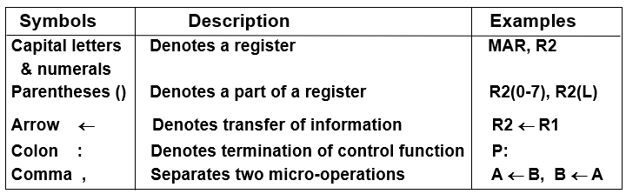

- BUS
Bus is a path(of a group of wires) over which information is transferred, from any of several sources to any of several destinations.
From a register to bus: BUS ← R

- ARITHMETIC MICROOPERATIONS
- Addition
- Substraction
- Increment
- Decrement
- LOGIC MICROOPERATIONS
bit-wise operations, i.e., they work on the individual bits of data
AND (∧), OR (∨), XOR (⊕), Complement/NOT

- SHIFT Microoperations
  - Logical shift(SHL, SHR)
  - Circular shift(CIL, CIR)
  - Arithmetic shift(ASHL, ASHR)
An arithmetic shift is meant for signed binary numbers (integer).
An arithmetic left shift multiplies a signed number by two.
An arithmetic right shift divides a signed number by two.

- Instruction Code
An Instruction code is a group of bits that instructs the computer to perform a specific operation.It is divided into parts.

- Operation Code
The operation code of an instruction is a group of bits that defines certain operations such as add, subtract, shift, and complement.

- An instruction code is usually divided into
operation code,
operand address,
addressing mode
  - Immediate: the operand is given in the address portion (constant)
  - Direct: the address points to the operand stored in the memory
  - Indirect: the address points to the pointer (another address) stored in the memory that references the operand in memory

- The effective address is the location of an operand of the instruction,

